RESOLUTION NO.__________

RE: CERTIFICATE OF APPROPRIATENESS UNDER THE
PROVISIONS OF THE ACT OF THE PENNSYLVANIA
LEGISLATURE 1961, JUNE 13, P.L. 282 (53
SECTION 8004) AND BETHLEHEM ORDINANCE NO.
3952 AS AMENDED.

WHEREAS, it is proposed to install new signs at 15 E Third Street.

NOW, THEREFORE, BE IT RESOLVED by the Council of the City of Bethlehem that a Certificate of Appropriateness is hereby granted for the work.

Sponsored by: (s)

(s)

ADOPTED BY COUNCIL THIS DAY OF

(s)
President of Council

ATTEST:

(s)
City Clerk

HISTORIC CONSERVATION COMMISSION

CASE # 573– It is proposed to install new signs at 15 E Third Street
OWNER/APPLICANT: Jessica Kroope / Signarama-Lehigh Valley

The Commission upon motion by Mr. Cornish seconded by Ms. Starbuck adopted the proposal that City Council issue a Certificate of Appropriateness for the proposed work described herein:
- The proposal to install new signs at 15 E Third Street was represented by Steve Stigliano from Signarama.
- The window on the far right, which is 45.5” x 108”, will have a vinyl sign and logo that is a maximum of 35” wide reading “H2O Hookah Lounge” in normal horizontal format. The height of the sign will be approximately 35.75” and retain the proportions of the design submitted.
- A similar but smaller sign will be installed in the display window on the left of the entrance in the right-hand, corner panel of glass. The sign will also be horizontally oriented and read “H2O Hookah Lounge” The glass panel is 23.5” x 108” in size and the sign will be a maximum of 18” wide x 18.5” high.
- Hours and other text planned for the front door will be 19.9” x 20.1” in size in white vinyl. The door glass is 22.5” x 62.5” in size.
- A revised drawing will be submitted to the Historic Officer for review before permitting and installation.
The proposed motion was unanimously approved.

CU: cu
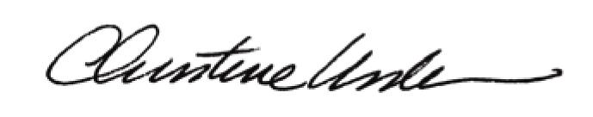

By:

Date of Meeting: December 21, 2015 Title: Historic Officer

